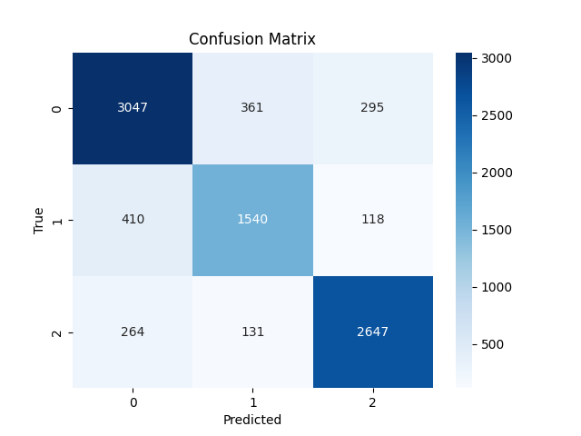

time stamp: 29.12.2024

epochs = 20

batch size = 50

accuracy = 82.0832

0-A, 1-FD, 2-C

As there is class imbalance in the datasets [36A's, 23FD's, 29C's] which might be the reasons for mis-predicted classes.

choosing ensemble learning over oversampling even it can increase computational costs

Reasons:

1. chances the data may not accurately represent the underlying patterns in EEG data on synthetic samples.
2. chances of overfitting and needs to check the weights again after oversampling to reduce the overfitting

checking with BalancedRandomForestClassifier

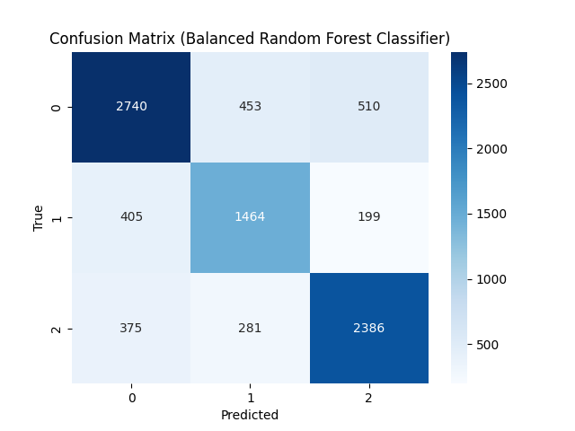

precision recall f1-score support

0 0.78 0.74 0.76 3703

1 0.67 0.71 0.69 2068

2 0.77 0.78 0.78 3042

accuracy 0.75 8813

macro avg 0.74 0.74 0.74 8813

weighted avg 0.75 0.75 0.75 8813

Accuracy: 0.7478